Master Gardener Thymes
www.lakelandsmastergardener.org
FEBRUARY 2006


MEETING CALENDAR
Meetings are held the 2nd Thursday of each month at the NW Volunteer Fire Department @ 6:30pm, unless otherwise noted. The Fire Department is located behind Harris Baptist Church off of Center Street.
FEBRUARY 9th—DEER PROOFING YOUR YARD with James Hodges. Come listen to James offer professional advice on keeping Bambi out of your garden this year. Continuing Education Credit.
FEBRUARY 23rd—Board Meeting @ 5:30pm at the Mall Office
MARCH 9th—General Meeting—Speaker to be announced
IF YOU HAVEN’T PAID YOUR 2006 MEMBERSHIP DUES OF $10.00, PLEASE DO SO IMMEDIATELY. YOU MAY GIVE THEM TO TERRI MOSTILLER AT THE GENERAL MEETING OR MAIL YOUR CHECK, MADE OUT TO LAKELANDS MASTER GARDENERS, TO HER AT:
617 COCHRAN ROAD DONALDS, SC 29638
_______________________________________________________________________________________________________________________

NEW OFFICERS FOR 2006
JANE PRICE—PRESIDENT
LAUREN TURNER—VICE PRESIDENT
TERRI MOSTILLER—TREASURER
KRIS CHEESEMAN—SECRETARY
LAUREN BOYLSTON—PAST PRESIDENT

These are your Board Members. Feel free to contact them
with your suggestions or concerns.

Recommended Reading

A Rock Garden in the South by Elizabeth Lawrence

Submitted By Benjamin Hawthorne

As most of you know, Ms Lawrence was one of the more renowned garden writers of the south. She gardened for most of her life in Raleigh, NC and then in Charlotte until her death in 1985. She wrote several books and was the garden columnist for the Charlotte Observer newspaper. This book was published posthumously from her notes by Duke University Press and has been edited and updated by Nancy Goodwin, another well-known southern horticulturist and nursery owner.
While she gardened in USDA zone 8, and we are in zone 7, her thoughts on southern gardening, with our heavy clay soils and hot, humid summers, are profound. One does not have to be a rock gardener to appreciate the book. Most rock garden plants are quite small in size so as not to obscure the rocks they are grown among. Today*s smaller, more compact gardens are able to utilize dwarf conifers, miniature bulbs and other smaller plants where traditional varieties might outgrow their allotted space too quickly. Ms Lawrence had first-hand experience with growing these plants and her insights are priceless.
The book has two sections. The first is a short treatise on Ms Lawrence*s whole outlook on rock gardening in the south. The second, larger section is an encyclopedia of plants suitable for southern rock gardens, and is particularly useful to me. This section has been updated and revised by Nancy Goodwin, with her comments in brackets under Ms Lawrence*s entries. The section on dwarf conifers and woody plants was edited and updated by Paul Jones, a horticulturist with the Sarah P. Duke gardens in Durham, NC. I enjoyed reading this book and can highly recommend it to anyone who gardens here in the south!

Other Recommendations Submitted by Jane Price:

Taylor's Guide to Shade Gardening Frances Tenenbaum, Editor Houghton Mifflin Company, Publisher
Hostas and Other Shade-Loving Plants Richards Bird and David Tarrent
A Guide to the Wildflowers of South Carolina Richard Dwight Porcher and Douglas Alan Raynor, Text Richard Dwight Porcher, Photographs

-1-

THE PRESIDENTS CORNER

Fellow Master Gardeners,
Hope that everyone had a great holiday season. I am looking forward to an exciting year for Lakelands Master Gardener Association. We started it off with a meeting of old and new committee chairs on January 10. We feel that we got a lot accomplished. On January 12 what a wonderful graduation we had. I want to say a big “Thank You!” to the Social Committee ( Patty Burton, Chris Moffitt, Evie Galloway, Julee Marshall, and Carol Ritz) for the job that they did getting the meat and beverage, setting up, decorating, and cleaning up. Also, to Lauren and James, thank you for the outstanding program. I know that it took a lot of hard work and effort. On January 14, some of us met at the Railroad Museum to make decisions about what will be done on that project. Sandra Johnson, chairman for that project, has so much enthusiasm that it is contagious. Debbie Ashley, Lee Natvig, and Diane Sibley were so excited they got started that afternoon pruning. On Jan 14, Patty Huff, community projects chairman, and I checked out some plants that John Willis, a fellow master gardener, will be donating to us to use in our projects. So, you see, a lot is already going on.
One of my main goals this year is to get more members involved in the activities of our association, and I need your help to do that. Please contact me and let me know what you want to see your organization doing. I am open to any suggestions and promise I will take those suggestions to the board. I invite you to please come to our next meeting and catch the enthusiasm!

Jane Price
President
Contact Jane at derf007@greenwood.net or 227-8992
_______________________________________________________________________________________________
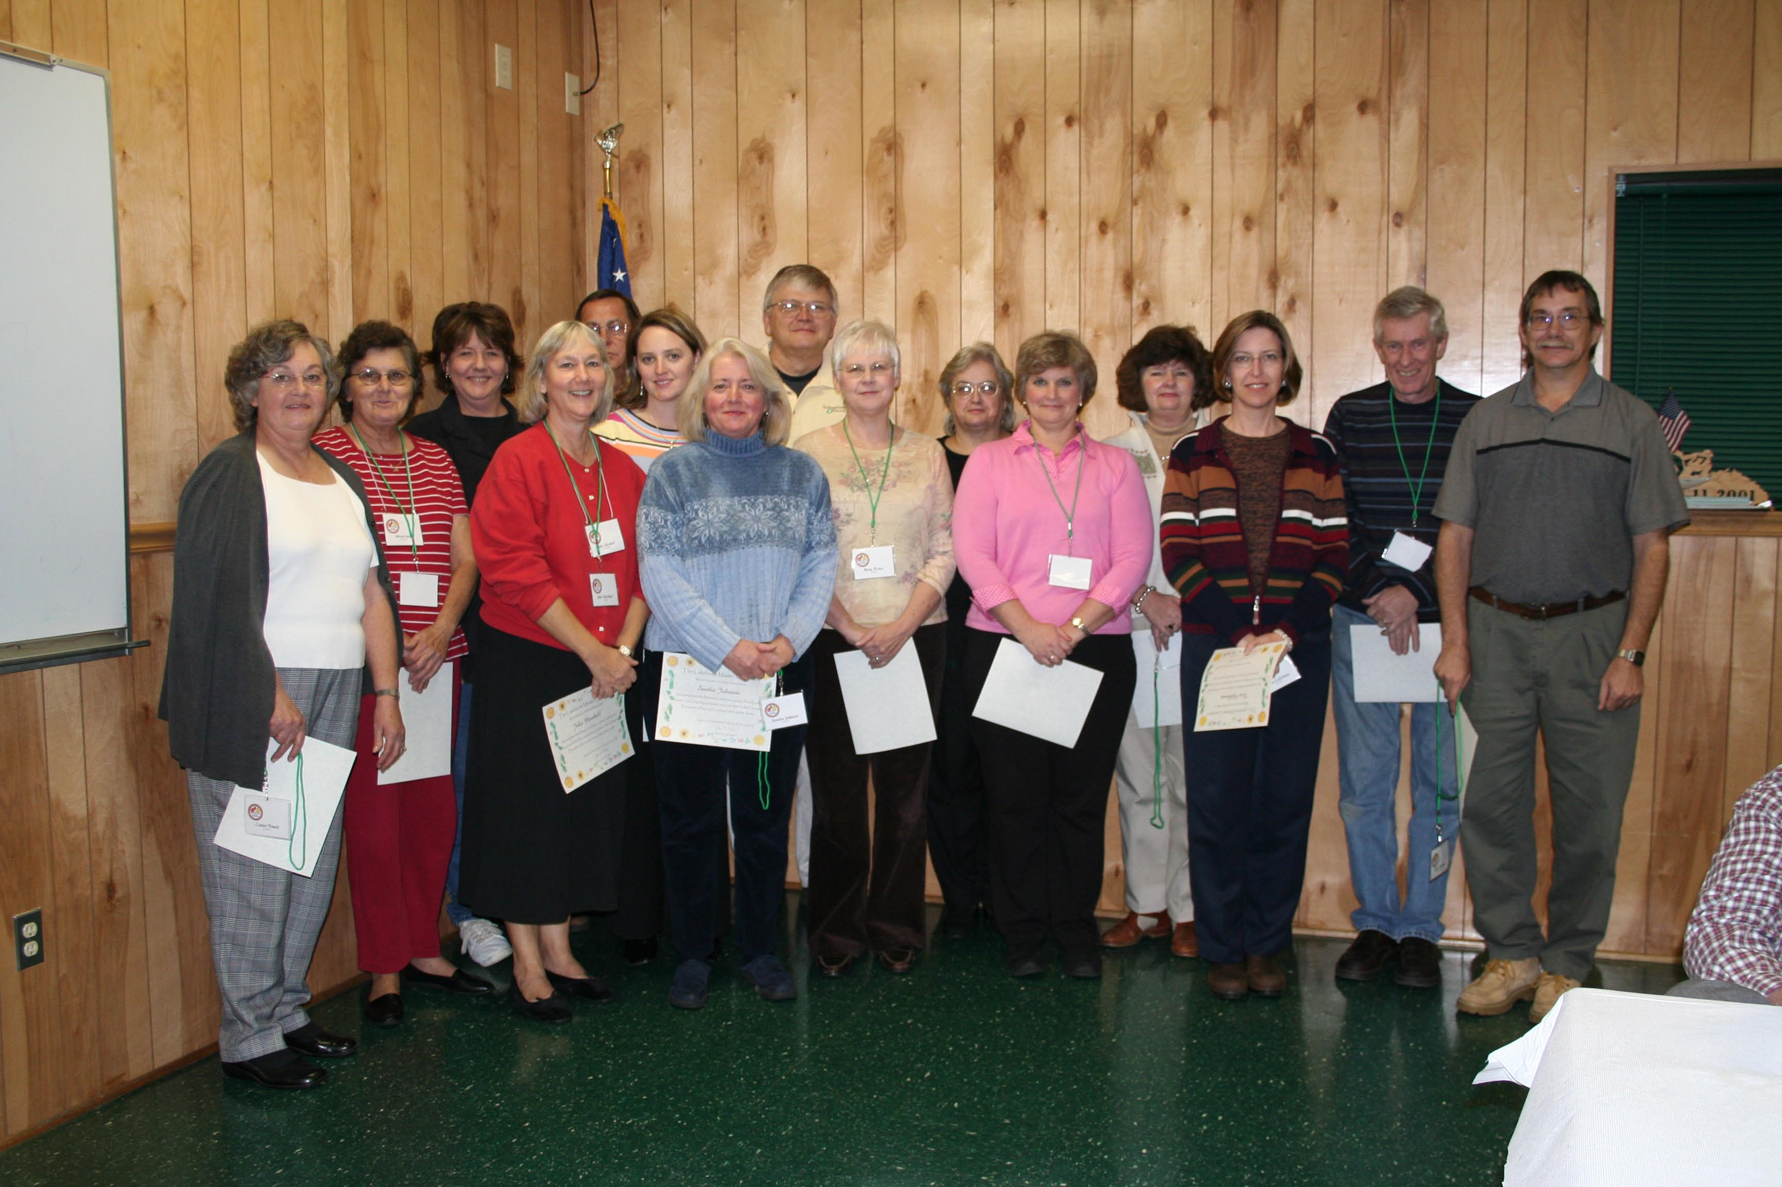
Congratulations to the 2005 Graduates

Debbie Ashley, Kris Cheeseman, Evie Galloway, Gene Garland, Kathy Hoffman, Sandra Johnson, Julee Marshall, Lee Natvig, Louise Powell, Ken Reece, Betty Reece, Cindy Rushton, Diane Sibley, Miriam Smith, Jeff Thomas, Lauren Turner, Bruce Walters, Sharon Warner and Don Webb.

Graduation Night January 12, 2006
Master Gardener Interns receiving their certification were: George Ardnt, Ann Cassell, Pamela Faulkner, Frankie Fisher, Nancy Gaffney, Betty Gantt, Patty Huff, Elaine Huntsberger, Salil Jha, Rebecca McLain, Michael McKenzie, Ann Mendelson, Terri Mostiller, Joe Palazola, Jim Ridgeway, Betty Sargent, Carol Scales, Sandy Stachurski, Susan Wallace, Lei Zimmerman, Scott Zimmerman, Sherry Kistler, Roberta McKee and Thomas Henderson. We all know how tough those first 40 hours are. Congrats to all of these wonderful members of our organization

Golden Gloves Award: Julee Marshall
Perfect Attendance: Jane Price
Incentive Awards: Linda Kellam and Lauren Boylston

Cumulative Hours Achievements: The following people passed the noted hours in volunteer service this year.
>250- Gail Murph, Mary O'Dell, Joyce Marshall, Catherine Swindell, Mike Brown, Glennis Cannon, Jim German, Mary Van Ellenburg, Ben Hawthorne and Lauren Boylston
>500- Judy Sieckman, Rebecca Lee Griggs, Sharon Alvarez and Tommy O'Dell
>750- Dot Gambrell (+800), Paula Lemond (+900) and Donna Boozer (+800)

PLANT GUIDE AVALIABLE ONLINE
Thanks to Paul Thompson (pthmpsn@clemson.edu), York County Extension Agent and MG Coordinator, you can identify trees, shrubs, vines and groundcovers of this region by clicking on: http://www.clemson.edu.hort/scmg/mgresources.php.
Plants are listed by both common and botanical names, and the guide is a great educational tool. Thanks Paul!!

-2-

CLEMSON EXTENSION AGENT CORNER

The Real Truth About “It Depends”

By James Hodges

IT SEEMS THERE IS A RUMOR THAT MY ONLY ANSWER FOR ANY PROBLEM OR PLANT QUESTION IS:
“ IT DEPENDS”.

In our world today there is a single treatment, pill, product, exercise, diet or simple solution for any personal, business, health, or plant problem you could possibly encounter. All for a great discount price + shipping and handling.

I want an honest show of hands out there. How many of you have bought into one of the types of products or services described above? OK, 100% have raised your hand; you’re all honest.

Are there usually single answer solutions to life’s problems or plant problems? If there were, then do you think I wouldn’t just give the simple solution? If only life and plants were so easy and simple.

Did you notice the curriculum in our Master Garden classes? I don’t think we had any presentations on a single new fertilizer, bio-stimulant, root mychoriza, compost, soil-less mix that will solve all plant growing problems. There isn’t a super plant for every need; any perfect tomato, shrub, grass or tree for everyone’s individual situation.

The phrase “IT DEPENDS” should be a reminder to each of us when we look to answer any gardening or plant question. Gather information before making a determination. Look, listen and analyze as much information that you can before applying treatments or giving quick answers.

Here is a good example: Every gardener’s habit of impulse buying when it comes to new plants. The next time you see a plant that you just have to try ask this question-- Will it be a great purchase? How do you know this?

My answer, “IT DEPENDS”. Do you know enough about the plant? Where will it fit? Can your home provide the proper growing conditions for this plant? Are you prepared to provide adequate growing and maintenance conditions? Is there space?

I’ll leave you with this question to ponder. Do you know why that impulse purchase plant in your backyard is having problems? I’ll bet.

Can you identify the female bird James has in his lap in the photo to the right? It flew into my window last spring when James happened to be at my house. It was stunned but recovered and was unhurt. I saw its mate at my feeders. Here is a clue: its mate is colored completely differently. This bird does not normally appear at home feeders nor does it nest in our area. But this pair stayed on my property for several months. Identify the bird and win a whimsical garden marker! Email your "guess" to Lauren Boylston at LBoylston@earthlink.net. GOOD LUCK!
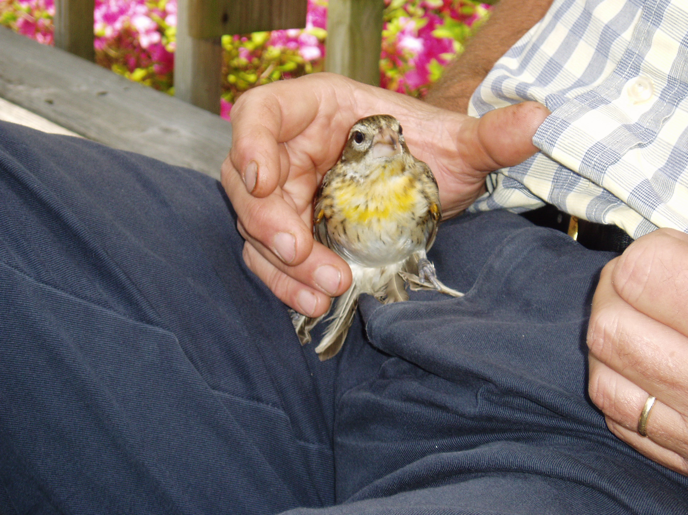

AN INTRODUCTION TO BEEKEEPING

Submitted by Donna Boozer

An "Introduction to Beekeeping" short course is planned at the Greenwood County Farm Bureau building, 211 Montague Avenue, Greenwood. This course is designed for hobby beekeepers and will be taught 7-9 pm on Thursdays, February 9 through March 16. A tour of the Clemson University Bee Lab will conclude the course on March 25. Topics to be covered include honeybee biology, beekeeping equipment, managing honeybees, nectar sources, insects and diseases affecting the honeybee and processing honey. Registration fee for the course is $40, which includes a reference book, "Beekeeping in South Carolina", and handout material. For information, contact the Clemson Extension Service office in McCormick at 465-2112, ex 112. Registration closed January 26th but call anyway if you are interested.

Do you have an announcement about an interesting program in our area? Please submit it for the next newsletter.

-3-

2006 Project Review

Submitted By Sandra Johnson
Railroad Historical Center
2006 Master Gardener Project

The Railroad Historical Center (RRHC) has been selected as one of the 2006 Master Gardener Community Service Projects. The RRHC property was given to The Museum in Greenwood by the family of the late L.B. and Angelle Adams in June of 2005. The property includes an historic house built in 1905, 2 outbuildings, a steam locomotive, a caboose, and 5 train cars. The property also includes a beautiful established garden that needs maintenance.

The Master Gardener project will include developing a landscape drawing of the existing site and identifying plants and shrubs to keep as well as pruning, clearing brush and ivy, cleaning beds, moving shrubs, etc.

The Board of Trustees of The Museum will open the RRHC every weekend by May 2006 (in the past the Center was open 1 weekend per month during the summer months). Plans are underway to host the Greenwood Chamber of Commerce Business after Hours in conjunction with the Palmetto Bank in May 2006. The celebration will focus on the fact that the Palmetto Bank and the Steam Locomotive No. 19 at the RRHC turn 100 in 2006.

The Center is located at 908 South Main Street in Greenwood. For more information on the RRHC project, contact Sandra Johnson at sandramjohnson@earthlink.net or 864.229.1248.

UPCOMING SCHEDULED WORKDAYS ON THIS PROJECT ARE: February 25th @ 10am and March 11th @ 10am
Bring tools and be prepared to dig!!!!

RECIPE CORNER

Many of you who attended the Christmas party and gift exchange had the pleasure of tasting the delicious herbed cheesecake brought by new member Julee Marshall. She has graciously passed this fattening delight along for all of us.

HERBED CHEESCAKE
Par 3 Tea-Time at the MASTERS®
For the crust, combine the flour, butter, salt, egg yolk and lemon zest in a bowl. Mix to form a dough. Press into the bottom and halfway up the side of an 8- or 9-inch springform pan. Freeze while preparing filling

For the filling, preheat the oven to 400 degrees. Beat the cream cheese in a bowl until smooth. Beat in the garlic, onion, parsley, Parmesan cheese and flour. Add the eggs 1 at a time, beating well after each addition. Beat in the salt, Tabasco sauce, lemon juice, basil, tarragon, oregano, rosemary, and pepperoni. Pour the filling into the prepared crust. Bake for 10 minutes. Reduce the heat to 325 degrees and bake for 50 minutes. Remove to a wire rack to cool. Remove ring or side and place on a serving dish or cake stand. Garnish with herb sprigs and serve with crackers
Published by Junior League of Augusta, Georgia

Crust
1 cup all-purpose flour
1/2 cup (1 stick) butter, softened
1/2 teaspoon salt
1 egg yolk
2 teaspoons grated lemon zest

Filling
24 ounces cream cheese, softened
2 garlic cloves, minced
1 onion, chopped
2/3 cup chopped fresh parsley
3 ounces Parmesan cheese, freshly grated
3 tablespoons all-purpose flour
4 eggs
1 teaspoon salt
1/2 teaspoon Tabasco sauce
2 tablespoons fresh lemon juice
1 tablespoon chopped fresh basil, or
1 teaspoon dried basil
1 tablespoon chopped fresh tarragon, or
1 teaspoon dried tarragon

Do you have a recipe to share? It need not be garden related but merely delicious.
We would like to have one new recipe a month from one of our members. Please email your recipe to LBoylston@earthlink.net

-4-

Favorite Shade-Lovers by Benjamin Hawthorne

This time of year the garden is so very dreary… mostly a bunch of dry sticks and dirt mounds! It is a time to appreciate the evergreens. Here are a few of my favorites for the shade garden:

Ajuga reptans: a very low-growing groundcover for well-drained hummusy soil. It has small blue tubular-shaped flowers, which give it its common name of “bugleweed”. This is such an endearing little plant...each has a low rosette of leaves and it blooms prettily in spring and sporadically thereafter. My favorite variety is “Atropurpurea” whose purple leaves go beautifully with Stachys “Big Ears” (I have found that this “lambs ears” does well in part shade). In recent years many new introductions have been made of this species, all involving variegations of its leaf colors. A few examples: “Arctic Frost” has silvery-blue leaves, very distinctive; “Black Scallop” has purplish-black leaves and “Linda Applegate” has almost apple-green leaves and white flowers. I have found this to be very tolerant of shade. In fact, I discovered a group of them had self-seeded in the dense shade between a holly and a Japanese cedar and they have been growing happily there for years!
Aspidistra elatior: This is also known as cast-iron plant…perhaps because it will thrive in poor soil and dense shade! In fact, too much sun will scorch its leaves. It is grown as a houseplant in the north but does well outdoors here. Again, breeders have come up with several varieties in recent years: “Variegated” has alternate stripes the length of its leaves; “Milky Way” is spotted; “Asahi” has the upper 1/4 of its leaves variegated in white. Very well behaved and dependable, a slow spreader and a nice backdrop to lighter-colored, lower-growing plants. Its leaves will look ratty after a cold winter, but they are easily trimmed away and new growth will replace them.
Fatsia japonica: a large, evergreen shrub for fairly dense shade. These are very fast growing and are perfect for shady house foundations. There is a variety called ”Variegated” which has white leaf margins and another called ”Spider’s Web” which has whitish leaf margins extending into the center of the leaf. In addition, breeders have made an intergenetic cross between Fatsia and Hedera hibernica (ivy) called Fatshedera. This is an evergreen shrub that grows like a vine with very large, evergreen leaves…very easy and attractive. I don’t think the fatshedera blooms but the fatsia features white umbrels in late fall.
Helleborus: a very lovely and under appreciated plant for the south! These are long-lived evergreens, they flower January through April and they re-seed prolifically! They take about 5 years to flower from seed. Again, they can look a little ratty after winter but a grooming in late spring will make them look presentable again. H. niger (AKA Christmas Rose) is white-flowered; H. foetidus has apple-green flowers and H. orientalis (AKA Lenten Rose) has mauve-pink flowers. In addition, there are numerous hybrids such as the “Royal Heritage” series, which have other flower colors. In my opinion, it is quite possibly the best over-all plant for light to medium shade.

TIME TO RELAX
Submitted by Judy Kelley

When you get stressed out from looking at all those wonderful seed and plant catalogs and then get into your actual gardening, try your hand at the puzzle of the month, a new feature added to our newsletter this year.

SMELL THE HERBS

K A H Q S H X R I T N D Q M C
ALOE ARNICA
BLOODROOT BORAGE
COMFREY DILL
GINSENG HORSERADISH
LOVAGE PARSLEY
ROSEMARY TANSY
THYME WINTERGREEN
WORMWOOD
H Y N W T S Q C O A A H I O X
R U E J H I I E L S W N M R N
R K J L U D S O R J E F S E O
P F V L S A E I Q M R M E Y P
B L O O D R O O T E P R A C T
U E T F F E A Y Y T G A U R H
Y P I M N S Y P G R Y C W S Y
X W W W X R Y T E E E I O M M
L L I D V O K T O G Q N R H E
M Y K H R H N O A C M R M F R
G N E S N I G R U Q Q A W D T
E X X S W L O V A G E Q O T D
E D A C C B C X M G D U O B A
I U M J O M K G L M Q W D Z Z

“Gardens, scholars say, are the first sign of commitment to a community. When people plant corn they are saying, let’s stay here. And by the connection to the land, they are connected to one another.” ---Anne Raver

-5-

MEET A MEMBER

Our new Vice President, Lauren Turner, grew up down the road in Laurens, South Carolina. After graduating from Presbyterian College in 2002 with a degree in Psychology and a minor in Biology, she took a position at Greenwood Genetic Center, where she still works. She married her husband Mike in 2004, making her a virtual newlywed. While she and Mike have no children yet, they do have a very cool cat named Tiger. They bought their first home in 2005 and Lauren says they have their work cut out for them when it comes to landscaping and getting things whipped into shape. This is one of the reasons she decided to take the Master Gardener course. She wanted to learn as much as she could about gardening so she and her husband can tackle their yard on their own. Lauren says she has really learned a lot so far and is looking forward to learning more as she makes friends and gets more involved with our group. Lauren can be found most mornings before 6am at Wellness Works doing her daily work out.

OUT AND ABOUT
South Carolina Botanical Gardens--Clemson

February 18th--9:45am to 10:30am
SHADE GARDENING IN THE PIEDMONT with Rekha Morris--Join Master Gardener and garden writer Rekha Morris to learn how to transform a shady area into a garden. Rekha's woodland garden provides comprehensive examples of how careful placement of shade-tolerant herbs and shrubs in the understory of oaks and hickories can create a beautifully diverse garden in the shade. She'll talk about how to evaluate shade levels, moisture requirements, and determine which plants should go where.
This is part of a three lecture series for this day, which includes a lecture on Annuals and Perennials with Jim Faust and Trees and Landscape Plantings with Ellen Vincent. Contact the Botanical Gardens in Clemson for more information. Cost is $15.00 for all three lectures, which begin at 9 and end at noon.

Editor: Lauren L. Boylston
LBoylston@earthlink.net

Lakelands Master Gardeners
PO Box 49632
Greenwood, SC 29648

