Master Gardener Thymes
www.lakelandsmastergardener.org

June 2008


ALL MEETINGS ARE HELD ON THE SECOND THURSDAY OF EACH MONTH, unless otherwise noted. PLEASE MARK YOUR CALENDARS!!!!!!!!

June 12th Meeting
Submitted by Rebecca McClain
Our June12th meeting will be held in the gardens of Gerald and Betty Dorn at 6:30pm. Their place is located at 234 Elliott St . , Greenwood . The Dorn’s yard contains a wide variety of trees. This will be an excellent opportunity for those taking the advanced tree class to test their new skills.
Mr. Dorn is a talented wood sculptor who has incorporated some of his favorite pieces into their landscape. The bronzed sculptures are arranged near their Koi pond.
Other points of interest include: plantings to attract birds and butterflies, landscaping along the railroad walking trail and artifacts collected while in Japan .

TIME IS RUNNING OUT!!!!
We have less than 1 month left for the ticket sales for the quilt and painting, so we need to get what we have left sold. Please go by the MG office at the mall or call Paul Drew. The drawing will be held on the 21st of June. Thanks. Chris Moffitt

AND SPEAKING OF TIME-----

Many of you have put in lots of time working on various community projects, helping neighbors, friends, and relatives and or furthering your horticultural knowledge this spring. It would be such a waist if time and miles went unreported and /or underreported. Please send in your hours and miles by June 15, so that our state will benefit from the significant contributions you have given to our communities.
Linda Halsey
P.O. Box 82
Hodges , SC 29653
864-374-7253
halseyfarm@gogenesis.com

ATTENTION ALL THOSE WHO HAVE VOLUNTEERED TO DISTRIBUTE VOUCHERS AT THE FARMER’S MARKET!!!
I have set up a training day on Tuesday, June 3rd at the extension office, Park Plaza, 3-4 PM.
I have contacted many who signed up by phone or email, but if I missed anyone please email or call me to remind me. If anyone still wishes to sign up let me know.
Thanks
James
Native Plant Alternatives
Copied from the Upstate Chapter of the SC Native Plant Society
Submitted by Sandy Stachurski

These native plants are suggested as alternatives to invasive exotic species in Upstate South Carolina.

Non-native invasive Native plant alternative

PRIVET, Ligustrum ssp. (ev)-
Carolina cherry laurel, Prunus caroliniana (ev)
Yaupon holly, Ilex vomitoria (ev)
Inkberry holly, Ilex glabra (ev)
Florida leucothoe, Leucothoe populifolia (ev)
Wax myrtle, Myrica cerifera (ev)

AUTUMN OLIVE and RUSSIAN OLIVE, Elaeagnus spp. –
Native plums, Prunus spp.
Possumhaw viburnum, Viburnum nudum
Blackhaw viburnum, Viburnum prunifolium
Winterberry, Ilex verticillata
Possumhaw holly, Ilex decidua
Native blueberries, Vaccinium spp.

JAPANESE HONEYSUCKLE, Lonicera japonica (ev)-
Carolina Jessamine, Gelsemium sempervirens (ev)
Coral honeysuckle, Lonicera sempervirens (ev)
Cross vine, Bignonia capreolata (ev)

BRADFORD PEAR, Pyrus calleryana-
Various hawthorns, Crataegus spp.
Serviceberry, Amelanchier spp.
Redbud, Cercis canadensis
Fringe tree, Chionanthus virginicus
Red maple, Acer rubrum
Southern sugar maple, Acer barbatum

(ev) = Evergreen or partial evergreen species

Phytoremediation
Submitted by Bibbi Lee
John P. Wiley, Jr. wrote some fascinating facts in the Smithsonian about how plants can clean up manmade messes:

Microbes are already gainfully employed cleaning up oil spills and the like. Artificial marshes are now being planted to further cleanse the effluent from sewage treatment plants. Plants are also cleaning up water draining from abandoned mines.

Plants can remove metals like cadmium from the soil and store them in their tissue and they can recover zinc later. Some plants convert the metals into gases and release into the atmosphere.

Poplars planted in strips will stop plumes of underground water contaminated with petroleum. They and other plants can also break down compounds like TNT (left behind by the military) into harmless, inert compounds.

Sunflowers floating on rafts with their roots dangling are used to remove cesium 137 and strontium 90 from a pond at Chernobyl.

Soil contaminated with lead, when amended with a substance that will bind the lead, will have a resulting compound that is taken up by Indian mustard. Sometimes the treatment will require just one summer.

The common cattail is used in artificial wetlands to clean up acidic wastewater from mine drainage. Cedar Rapids, Iowa, has constructed a tertiary treatment for the effluent from its conventional septic system. The initial basin is planted with cattails and bulrushes. The second basin has arrow arum, blue and yellow iris, water plantain, cardinal flower, great blue lobelia, ironweed, swamp milkweed and sweet and march blazing-star liatris. The flow ends of the pond are planted with water plantain, arrow arum, sweet flag, march marigold, lizard’s tail and arrowhead. The banks are planted with a variety of goldenrod, coneflowers, asters, and shrubs.

What a great looking sewage treatment plant that would be!

The Gardening Addict
By
Jane Price

Well, it has finally happened, ya’ll. I have become a full blown gardening addict! It was about eight years in the making. It started out very innocently with my taking the Master Gardener course. It has gone from the simple task of planting a single plant to relandscaping my entire yard, building retaining walls, bridges, digging ditches, etc. They say admission is the first step to cure, but I have a feeling I am never going to be cured of this. Would you like to know how to tell when you have become a gardening addict? Well, here goes:
- In the spring (or should I say, January) instead of your thoughts turning to
love, they turn to GARDENING! And stay there all year long.
- When you get up in the morning, instead of saying, “What am I going to
have for breakfast?” You say, “Now where am I going to plant that fern?”
- From the end of May through June your fingers are stained purple from
picking spent daylily blooms.
- At the end of the month when you are running out of cash and have to decide
whether you will buy groceries or that garden bench, you opt for the garden
bench.
- You’re late for an important meeting (in my case, a Master Gardener board
meeting) because you are working in your garden and lost track of time and everything else.
- You look down at your hands in church, or what the heck, anywhere, and
there is dirt under your nails that just won’t come out.
- Your husband yells out into the back yard (EVERYDAY at 5:00) and says, “What are we having for dinner?” and your response is: “How ‘bout sticking a Stouffers in the oven.”
- Your non-gardening friends won’t call anymore because all you can talk about is
gardening.
- Your non-gardening friends are getting ready to call DSS because of the many
bruises all over your body.
(10)When you pass a garden center, your car automatically turns in.

Well, I could go on and on, but I am probably beginning to bore you. As the guy says in
the TV commercial, “SOMEBODY, PLEASE HELP ME!”

(ed. Note: I didn’t know Jane knew me so well!!!! J.)

The Torrey Pine
Excerpt from an article on www.USOPEN.com
Submitted by Stuart Menaker
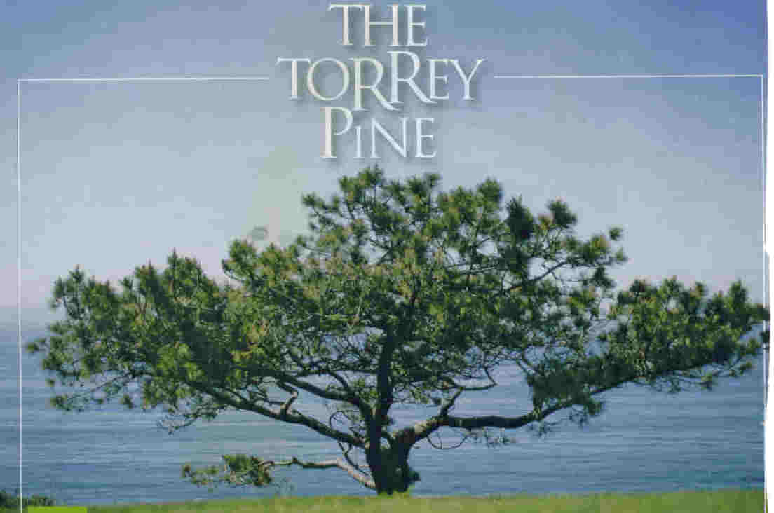
The Torrey pine is quite a tree. It’s not the rarest tree in the United States (that honor goes to the Monterey Cypress), nor the rarest pine in the world (a Vietnamese species owns that medal). No, the Torrey Pine is simply an admirable product of Mother Nature.
It manages to thrive in dry, sandy, unforgiving soil. It survives a constant broiling from the southern California sun. It tolerates a hammering from gusting winds blowing from both the Pacific Ocean and the parched land to the east.
Early Spanish explorers referred to the San Diego area as “Punto de Los Arboles” –the “point of trees” –as copses of any form of plant in this barren part of the world were few and far between. Some reports claim that ships would use the pines as lighthouses, their appearance alerting navigators to the proximity of land.
Later, as the area became settled by Americans, the trees became known as “Soledad Pines” – “solitary pines”. That name held until Dr. Charles Christopher Parry arrived in San Diego.
Parry, born in England, was working with the U.S.-Mexico Boundary Survey, as a surgeon and a botanist. He’d studied botany in New York with a professor named Dr. John Torrey. When Parry was introduced to the soledad pine, he decided to name it after his botanist mentor, John Torrey. Among many other offices, Torrey held the position of president of the Torrey Botanical Club, still considered to be the oldest botanical society in the U.S. Torrey died in 1873 without ever seeing the tree named after him.

Long term Climate effects on Trees
Submitted by James Hodges

As I drive around the Lakelands and other areas of South and North Carolina, I notice many trees that aren’t healthy this year. Likely, most of these trees are still trying to recover from the late freeze and drought of 2007. It is unfortunate that many of these aren’t your ordinary trees, such as sweet gum or pine, but favorite exotics such as Japanese maples, Crape myrtles or Weeping willows. The one native to add to this group is our Dogwood.
Many damaged or poorly performing trees have significant branch tip dieback and thin crowns. Others have lost more than half their live crowns, while a few did not even put out new foliage this year. I had one call from a dismayed man whose 25-30 year old specimen Japanese maple was leafless in early May. Another emailer asked what to do about pruning another Japanese maple with dead branches in the top half of the tree.
The most recent tree species that I have noticed is the Weeping willow. Death, top dieback and bark splitting are noticeable on many trees this spring. Weeping willow is marginally adapted to our hotter climate in South Carolina. Large, specimen trees are rare this far south as a combination of heat, drought, insects, disease and beavers shorten their live span. Last year was even more difficult for them as a species.
Adaptability of non-natives is more than average temperatures or rainfall. The southeast is notorious for its wide swings in temperatures and rainfall. Average climatic conditions may seem to match those of non-natives, but it is the extremes that will cause difficulties with them. Native forest trees such as dogwood also suffer ill effects when planted in totally different landscape conditions that have heavy grass competition, compacted soils and poor water availability.
Full recovery of damaged plants will be quite variable, depending on whether the damage was freeze damage, heat and drought damage or a combination of both. Prognosis for trees that have lost 50% or more of their crown is poor at best since insects and diseases often follow climate damage and finish the plants off. Improved management may make a positive difference on plants less affected, but long term adaptability will always be an issue with exotics and trees planted offsite (planted in conditions for which that are poorly adapted for genetically).
I am not advocating against these four tree species or other non-native tree species, but merely pointing out the need to recognize that they carry a higher risk of early loss than one might expect when looking over your typical species information included in reference materials and sales catalogs.
You can and should improve their chances where possible with improvements in plant management such as soil improvement which provides better rooting and water and nutrient uptake. More attention to water needs during hot weather should be part of your management plan for these plants. Avoid planting locations (unless they can be significantly improved) that don’t provide a good root growing environment. Crape myrtle is the only one of these four that does tolerate poorer soils and hot locations, but selecting good cultivars is important if you want long lasting good looking specimens. Use references such as Clemson’s HGIC site http://hgic.clemson.edu to select cold hardy and insect and disease resistant cultivars of Crape myrtle that then meet your flower color choice.
Finally, remember there are no perfect plants, but as gardeners, armed with good plant growing techniques we can improve our chances of producing the desirable trees we seek.

Gardening Quote for June

The wise gardener is he whom years of experience have succeeded in teaching that plants, no less than people , have perverse individualities of their own, and that, though general rules may be laid down, yet it is impossible ever to predict with any certainty that any given treatment is bound to secure success or failure. Reginald Farrer 1920

Some Gardening Websites You Might Want to Check Out

www.virtual.clemson.edu/groups/hort/homehort.htm
www.clemson.edu/hort
www.gardening.com
www.garden.org
www.garden.com
www.hubcap.clemson.edu/UHC/extb1.htm
www.unc.edu/depts/biology
www.gardenguides.com
www.cornell.edu/VPR/vpr.html
www.mailserver.cog.brown.edu/gardening
www.sbmfaq.dvol.com/index.htm
www.plantideas.com

If you try any of these links and it doesn’t work, let me know so I can correct it. If you have a favorite website that has good gardening information, pass that on to me so I can share it. J.

Editor’s Note
Submitted by Jean Anderson

For those of you who prefer the 2-column style of newsletter, it will be back!! The excellent chart Sandy shared with us would not fit in the 2 column style. Part 2 of the chart will be in the July newsletter, and then, hopefully, the 2 columns will return in August. Also, I am using a new word processing program so that everyone will receive the same form. I appreciate your patience as I “work out the kinks.”

Lakelands Master Gardeners
PO Box 49632
Greenwood, SC 29648

